Development in diagnostic tests to distinguish between vaccinated animals and animals infected with mycobacterium bovis
Ashraf, A. Abd El-Tawab¹, Sahar, R. Mohamed², Heba, A. Mosalam³
¹Bacteriology, Immunology and Mycology Dep.,Fac. Of Vet.Med., BenhaUniv.
²Animal Health Research Institute, Dokki
³General Organization For Veterinary Services, Dokki
Abstract
One thousands cattle (400 from El-Menufia governorate, 320 from El-Gharbia governorate, 280 fromKafr El-Sheikh governorate) were tested by single intradermal cervical tuberculin test by using bovine PPD. The results revealed that 107 (10.7%) animals out of 1000 animals were positive to bTB. It is proved that Kafr El-Sheikh governorate had the highest percent of positive cases 12.1% (34/280) followed by El-Gharbia governorate with a percentage of 10.6% (34/320) while in El-Menufia governorate could detect 9.8% (39/400) positive bTB cases. Gamma interferon assay wascarriedouton heparinized whole blood samples collected from 107 animals that were positive to single intradermal cervical tuberculin test, the results revealed that 19 animals, out of 107 animals were positive to gamma interferon assay with percentage of (17.8 %). Results of serotest showed that El-Menufia governorate had a higher percent of positive tuberculosis cases 23.1% (9/39) followed by El-Gharbia governorate with a percentage of 17.6% (6/34) While in Kafr El-Sheikh governorate detect 11.8% (4/34) positive bTB cases. Gene expression of IFN-γ by RT-PCR revealed that the fold change 2.86 and 3.29 means the expression of IFN-γ in the samples is 2.86 and 3.29 than the expression of IFN-γ in the control samples respectively. ELISA wascarriedouton serum samples collected from 107 animals that were positive to single intradermal cervical tuberculin test, the results revealed that 16 (14.9%) animals out of 107 animals were positive to ELISA. It is declared that El-Menufia governorate had the highest percent of positive tuberculosis cases 20.5% (8/39) followed by El-Gharbia governorate with a percentage of 14.7% (5/34). While in Kafr El-Sheikh governorate the ELISA could detect 8.8% (3/34) positive bTB cases. The results of culture of milk samples of the tuberculin positive animals (15) cultivated on Lowenstein-Jensen media, resulted in (9) Lowenstein-Jensen media positive (60%) and (6) negative. The results of conventional PCR on (9) media positive revealed that five samples were positive for bTB and four samples were negative.
Key words: Bovinetuberculosis, gamma interferon, ELISA, PCR.
1. Introduction
Tuberculosis is a re-emerging disease causing growing public health burden (Abdel-Moeinet al. 2016). Mycobacterium tuberculosis complex, including M. bovis, M. tuberculosis, M. africanum, M. canettiandM.micoti are responsible for tuberculosis, as a chronic disease that represents both animal health problem and a serious public health problem in the world (ElSifyet al. 2013).
In Egypt, there are two methods for detecting of BTB; one is skin (single cervical tuberculin) testing of cattle through surveillance programme which mainly covers the individual cattle of smallholders. The other method is through slaughter surveillance that is entirely based on meat inspection at the slaughterhouse (Abdellrazeqet al. 2016).
Enzyme linked immunosorbent assay (ELISA) is one of the main important serological tests for diagnosis of BTB. It was applied as a sensitive method for measurement of antibodies in sera of tuberculous animals (ElSify et al. 2013). Many recent techniques were used for detection of mycobacteria to overcome the disadvantages of conventional methods. Also, the interferon-gamma (IFN-γ) assay has been included as complementary diagnostic tool to reinforce the skin test findings (Coad et al. 2008).
Polymerase Chain Reaction (PCR) is the most promising technique for rapid and specific detection of Mycobacterium in milk samples ( Parraet al., 2005). It has strong impaction on epidemiology, treatment and prevention of diseases in veterinary practice (Amin et al. 2015).
So the aim of the present study was for evaluation of diagnostic tests to distinguish between vaccinated animals and animals infected with mycobacterium bovis.
2. Materials And Methods
1- Animals:
A total of 1000 cattle were tested by single intradermal tuberculin test on two phases. The first phase was conducted on the total 1000 animals (400 animals from El-Menufia Governorate, 320 from El-Gharbia Governorate and 280 animals from Kafr El-Sheikh Governorate), the positive tuberculin reactor animals were slaughtered and the remaining negative tuberculin reactors composed the second phase of tuberculin test and were tested two months following the first phase.
2- Tuberculin skin test (SID) according to Monaghan et al., (1994).
3- Samples:
a- Blood samples: Collection of blood and serum samples according to Henry (1979).
b-Milk samples: Culture of milk samples according to Quinn et al. (1994) and Corner et al. (1995).
4- Laboratory investigation:
a- Gamma interferon assay for diagnosis of bovine tuberculosis:
(According to BOVIGAM® Mycobacterium bovis Gamma Interferon Test Kit for cattle):
BOVIGAM® is rapid in vitro blood based assay of cell mediated response to M. bovis PPD tuberculin for the diagnosis of bovine tuberculosis infection in cattle. Tuberculin PPD antigens are presented to lymphocytes in whole blood culture.
The production of IFN-γ from the cells is then detected using a monoclonal antibody-based sandwich enzyme immmunoassay (EIA). Lymphocytes from cattle not infected with M. bovis do not produce IFN-γ. Therefore detection of IFN-γ correlates to M. bovis infection.
b- Using SYBR Green real time PCR (gene expression of IFN-γ by PCR) according to Yuan et al., (2006).
c- Serodiagnosis of bovine tuberculosis by ELISA (Indirect ELISA was carried out according to Daniel and Debanne, (1987).
d- Using conventional PCR for milk samples according to Sambrooket al., (1989).
3. Results
3.1. Results of tuberculin test in different governorates:
Diagnosis of bovine tuberculosis by single intradermal cervical tuberculin test using bovine PPD results in 107 (10.7%) animals out of 1000 animals were positive to bTB. It is declared that Kafr El-Sheikh governorate had the highest percent of positive tuberculosis cases 12.1% (34/280) followed by El-Gharbiagovernorate with a percentage of 10.6% (34/320) while in El-Menufiagovernorate could detect 9.8% (39/400) positive bTB cases as shown in table (1).
3.2. Results of Gamma interferon assay on whole blood samples:
Results in table (2) revealed that 19 animals, out of 107 animals tested by gamma interferon assay on whole blood samples, were positive to bovine tuberculosis with percentage of (17.8%). El-Menufia governorate showed higher percent of positive cases 23.1% (9/39) followed by El-Gharbia governorate with a percentage of 17.6% (6/34) While in Kafr El-Sheikh governorate detected 11.8% (4/34) positive bTB cases.
3.3. Results of gene expression of IFN-γ by PCR (SYBR green real time PCR):
Amplification curves and ct values were determined by the stratagene MX3005P software.To estimate the variation of gene expression on the RNA of the different samples, the CT of each sample was compared with that of the control group according to the "ΔΔCt"method and to determine the fold changes as shown in table (3).
- The fold change 2.86 means the expression of IFN-γ in sample (2) is 2.86 than the expression of IFN-γ in control sample.
- The fold change 3.29 means the expression of IFN-γ in sample (3) is3.29 than the
expression of IFN-γ in control sample.
3.4. Results of ELISA on serum samples:
Concerning to serological diagnosis by ELISA on serum samples using commercial mixture Ag, results in 16 (14.9%) animals out of 107 animals were positive to bTB. It is declared that El-Menufia governorate had the highest percent of positive tuberculosis cases 20.5% (8/39) followed by El-Gharbia governorate with a percentage of 14.7% (5/34). While in Kafr El-Sheikh governorate the ELISA could detect 8.8% (3/34) positive bTB cases as shown in table (4).
3.5. Results of Conventional PCR on milk samples:
From 43 animals collected from different governorates El-Menufia (21) – El-Gharbia (12) – Kafr El-Sheikh (10) apply single intradermal cervical tuberculin test, it results in tuberculin test positive 15 animals and tuberculin test negative 28 animals then from the milk of the tuberculin test positive 15 animals cultivated on Lowenstein-Jensen media, it results in Lowenstein-Jensen media positive 9 (60%) and Lowenstein- Jensen media negative 6 then from the milk of Lowenstein- Jensen media positive 9 apply Conventional PCR, it results in 5 samples positive for bTB and 4 samples negative for bTB as shown in tables (5), (6), (7).
4. Discussion
Bovine tuberculosis (TB) is still a zoonotic problem in the world. Despite the fact that eradication programs for bovine TB are being implemented in many countries, it remains a public health problem. These programs are mainly based on detection of infected animals by single intradermal tuberculin test using bovine tuberculin purified protein derivative (PPD), this beside isolation and slaughtering of infected animals. (Cagiola et al., 2004). Bovine tuberculosis infection in cattle usually diagnose in the live animals on the basis of delayed hyper sensitivity reaction which is the standard method for detection of bovine tuberculosis. Although intra-dermal tuberculin test has been the widest used diagnostic technique, but it lacks sufficient sensitivity and specificity in many cases. Tuberculin test depends on several factors, including high quality reagents, as well as the immunological status of the animal. Furthermore, negative tuberculin test does not mean that the animal is not infected ; on the other hand, a positive test can only mean a delayed hypersensitivity reaction due to previous exposure.( Pandy et al., 2013).
Field trials have been conducted in different countries, and the results obtained suggest that the IFN-γ assay is more specific than the skin test.(Wood and Jones 2001). The assay is based on the release of IFNγ from sensitized lymphocytes during a 16-24 hours incubation period with specific antigen and makes use of comparison of IFNγ production following stimulation with avium and bovine PPD. Besides high logistical demands (culture start is required within 24 h after blood sampling), and its high costs, showed the same difficulties in the standardization already discussed in relation to the TST with the tuberculin.(Schiller et al., 2010).TheINFγ assay proved to be a very useful diagnostic method to be incorporate in a control and eradication program for bovine tuberculosis, due to the adaptability of its use to different epidemiological situations. Moreover, the parameters studied here demonstrated that the INFγ assay is applicable to frequently tuberculin-tested cattle in areas where blood samples could be processed within 24h from collection. ( Lopes et al., 2012).
The detection of mRNA is an alternative method of demonstrating cytokine induction. Recently, the reverse transcription (RT) of mRNA into DNA, followed by PCR using real-time PCR has become the method of choice for the rapid analysis and quantified RT-PCR. (Nolan et al., 2006). The real-time qPCR test is a gene-expression assay, it has the advantage over the ELISA test in that there is no need to prepare and use the relevant monoclonal antibodies. It is reported that real-time qPCR assay is useful in diagnosing multiple tuberculosis-infected animals (Harrington et al., 2007). However, the results of real- time qPCR are also affected by the status of the individual animal such as immunity alteration (Rothelet al., 2008) much like the ELISA. Other factors may affect reverse transcription PCR and fluorescence quantitative PCR, such as different enzyme reagent and use of different PCR instruments (Valasek and Repa 2005).
The ELISA technique can be used as a complementary to the tuberculin skin test to determine the disease status of animal or as a rapid screening test for herd testing program.the evident of low specificity and sensitivity of the ELISA make it of little value as an alternative to the tuberculin test, but it can detect some anergic cattle at the cost of increasing the number of false positive reactors. This may be acceptable in some circumstances and would justify the use of the ELISA as a complement test to the tuberculin test or to an in vitro assay of T-cell immunity.(Plackettet al., 2008).the use of ELISA was not effective for the diagnosis of bovine tuberculosis. The use of both ELISA and IFN-γ tests in parallel study allows detection of a greater number of infected animals before they become a source of infection for other animals as well as a source of contamination of the environment (Abo sherif 2014).
We can concluded that:
- Using of Gamma interferon assay was able to detect more positive animals indicating that it is more sensitive than SICTT and ELISA tests.
- The IFN-γ mRNA RT-qPCR was assessed to have a higher sensitivity and accuracy than the SIDT. Although several limitations have been identified which might be improved including identification of a gold standard and use of M. bovis-specific antigens, it can be used in the detection of M. bovisinfection in cattle as a complement.
- Using of Real time PCR is much faster, reducing the time for diagnosis two days and providing the ability to detect the presence of Mycobacterium bovis in samples even when organisms have become non viable for culture or when there is an overgrowth by other mycobacteria or low number of mycobacteria present in the sample, as well as they are more sensitive and specific.
5. References
Abdellrazeq, G.S., Elnaggar, M.M., Osman, H.S., Davis, W.C. and Singh M. (2016): Prevalence of Bovine Tuberculosis in Egyptian Cattle and the Standardization of the Interferon-gamma Assay as an Ancillary Test. Transboundary and Emerging Diseases. 63, 497–507.
Abdel-Moein, K.A.; Hamed, O. and Fouad, H. (2016): Molecular detection of Mycobacterium tuberculosis in cattle and buffaloes: a cause for public health concern. Trop Anim Health Prod.
Abosherif, Eman M. A. (2014): Role of raw milk in transmission of tuberculosis to man. PH. D. Thesis. Zoonoses. Fac. Vet. Med. Sadat City Univ. Egypt.
Amin, R.A.; Nasr, E.A.; El-Gaml, A.M. and Saafan, E.M. (2015): Detection of Tuberculosis in slaughtered food animals by using recent technique. BenhaVetetrinary Medical Journal. 28(2):129-134.
Cagiola, M.; Feliziani, F.; Severi, G.; Pasquali, P. and Rutili, D. (2004): Analysis of possible factors affecting the specificity of the gamma interferon test in tuberculosis free cattle herds. Clinical and Diagnostic Laboratory Immunology 11(5), 952-956.
Coad, M., S. H. Downs, P. A. Durr, R. S. Clifton-Hadley, R. G. Hewinson, H. M. Vordermeier, and A. O. Whelan, (2008): Blood-based assays to detect Mycobacterium bovis-infected cattle missed by tuberculin skin testing. Vet. Rec. 162, 382-384.
Corner, L. A.; Trajstman, A. C. and Lund, K. L. (1995): Determination of the optimum concentration of decontamination for the primary isolation of Mycobacterium bovis. New Zealand Veterinary Journal, v. 43, n. 1, p. 129-133.
Daniel, T. M. and Debanne, S. M. (1987): The serodiagnosis of tuberculosis and other mycobacterial diseases by ELISA. Am. Rev. Resp. Dis., 135: 1137-1151.
ElSify A., Nayel M., Hazem S., Tarabess R., Akram S., Allaam M., Hassan H., and El Garhy M. (2013): Sero-diagnosis of bovine tuberculosis by ELISA using bovine PPD and ST.CF. BS. VET. MED. J 7TH SCI. CONS. VOL. 22, NO.1, P. 126-129.
Harrington, N.P.; Surujballi, O.P.; Waters, W.R.and Prescott, J.F. (2007): Development and evaluation of a real-time reverse transcription-PCR assay for quantification of gamma interferon mRNA to diagnose tuberculosis in multiple animal species. Clin Vaccine Immunol. 14 (12):1563-71.
Henry, J.B. (1979): Clinical diagnosis and management by laboratory methods, volume 1, p. 60.
Lopes L.B., Alves T.M., Stynen A.P.R., Mota P.M.P.C., Leite R.C. and Lage A.P. (2012): Parameter estimation and use of gamma interferon assay for the diagnosis of bovine tuberculosis in Brazil.PesquisaVeterináriaBrasileira 32(4):279-283.
Monaghan, M.L., Doherty, M.L., Collins, J.D., Kazda, J.F. and Quinn, P.J. (1994): The tuberculin test. Vet. Microbiol. 40: 111-124.
Nolan, T., R. E. Hands, and S. A. Bustin. (2006): Quantification of mRNA using real-time RT-PCR. Nat. Protoc. 1:1559–1582.
PandeyS.Girja, Bernard M. Hang'ombe, Festus Mushabati and Andrew Kataba (2013): Prevalence of tuberculosis among southern Zambian cattle and isolationofMycobacterium bovis in raw milk obtained from tuberculin positive cows. Veterinary World, EISSN: 2231-0916.
Parra A, Larrasa J, García A, Alonso JM, de Mendoza JH, (2005): Molecular epidemiology of bovine tuberculosis in wild animals Spain: a first approach to risk factor analysis. Vet Microbiol110: 293–300.
Plackett P, Ripper J, Corner LA, Small K, de Witte K, Melville L, Hides S, Wood PR (2008): An ELISA for the detection of anergictuberculous cattle. Aust. Vet. J. 66: 15 – 19.
Quinn, P. J.; Carter, M. E.; Markey, B. and Carter, G. R. (1994): Mycobacterium species. Clinical veterinary microbiology.London:Wolfe, P. 156-169.
Rothel J., Jones, S., Corner, L., Cox, J., Wood, P. (2008): The gamma-interferon assay for diagnosis of bovine tuberculosis in cattle: conditions affecting the production of gamma-interferon in whole blood culture. Australian Veterinary Journal 69, 1–4.
Sambrook, J.; Fritscgh, E.F.;andMentiates (1989): Molecular coloning. A laboratory manual.Vol !., Cold spring Harbor Laboratotry press, New York.
Schiller, I., Oesch, B., Vordermeier, H.M., Palmer, M.V., Harris, B.N., Orloski, K.A., Buddle, B.M., Thacker, T.C., Lyashchenko, K.P. and Waters, W.R., (2010): Bovine tuberculosis: a review of current and emerging diagnostic techniques in view of their relevance for disease control and eradication. Transboundary and Emerging Diseases, vol. 57, no. 4, pp. 205-220.
Valasek, M. A., Repa, J. J. (2005): The power of real-time PCR. Advances in Physiology Education29, 151–159.
Wood, P.R. and S.L. Jones, (2001):Bovigam : an in vitro cellular diagnostic test for bovine tuberculosis. CSL Animal Health, Parkville: Victoria, Australia, 81: 147-155.
Yuan, J.S.; Reed, A.; Chen, F. and Stewart, C.N. (2006):Statistical analysis of real-time PCR data. BMC Bioinformatics, 7:85.

Table (1): Results of tuberculin test of cattle in different governorates:
Percent of tuberculin test Positive  % | Tuberculin test Negative | Tuberculin test Positive | Number of examined dairy cattle | Governorate
9.8 | 361 | 39 | 400 | El-Menufia
10.6 | 286 | 34 | 320 | El-Gharbia
12.1 | 246 | 34 | 280 | Kafr El-Sheikh
10.7 | 893 | 107 | 1000 | Total

Table (2): Results of gamma interferon assay on whole blood samples:
Governorates | Samples | No. of tested animals | Animals Positive for gamma interferon assay
 |  |  | No. | %
El-Menufia | Whole blood  (heparinized) | 39 | 9 | 23.1
El-Gharbia |  | 34 | 6 | 17.6
Kafr El-Sheikh |  | 34 | 4 | 11.8
Total |  | 107 | 19 | 17.8
Table (3):Results of gene expression of IFN-γ by PCR:
Samples | ß2M | IFN-γ
 | CT | CT | Fold change
1 (control) | 20.54 | 23.17 | -
2 (Infected) | 23.65 | 24.76 | 2.8679
3 (Infected) | 24.32 | 25.23 | 3.2944

Table (4): Serodiagnosis of bovine tuberculosis by ELISA:
Governorates | Samples | No. of tested animals | Positive ELISA(by commercial mixture Ag)
 |  |  | No. | %
El-Menufia | Serum | 39 | 8 | 20.5
El-Gharbia |  | 34 | 5 | 14.7
Kafr El-Sheikh |  | 34 | 3 | 8.8
Total |  | 107 | 16 | 14.9

Table (5): Results of culture of milk samples from cattle of different governorates:
Tuberculin test  Negative | Tuberculin test  Positive | Number of  examined dairy  cattle | Governorate
14 | 7 | 21 | El-Menufia
7 | 5 | 12 | El-Gharbia
7 | 3 | 10 | Kafr El-Sheikh
28 | 15 | 43 | Total

Table (6): Percentage of Mycobacteria isolated from milk samples using conventional cultural method:

Percent of Lowenstein- Jensen media positive  ( % ) | Lowenstein- Jensen media
 | negative | positive
60 | 6 | 9 | Tuberculin test  positive (15)

Table (7): Results of Conventional PCR on milk samples:
Sample No. | Sample type | Results
1 | milk | +
2 |  | +
3 |  | _
4 |  | +
5 |  | +
6 |  | _
7 |  | +
8 |  | _
9 |  | _

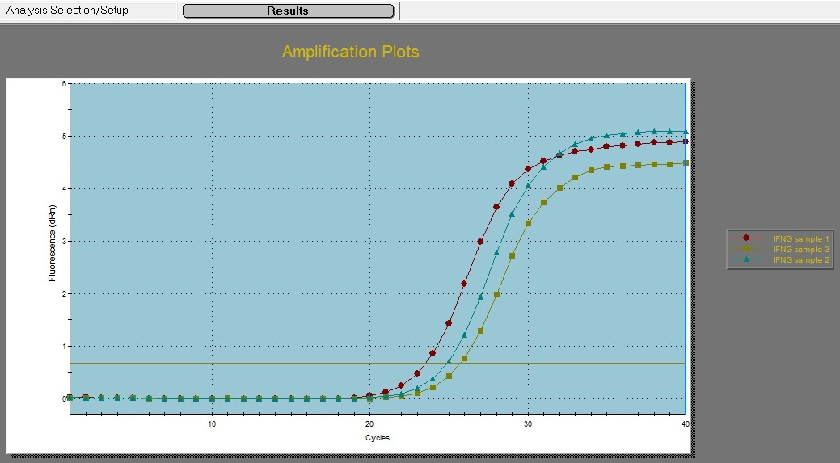
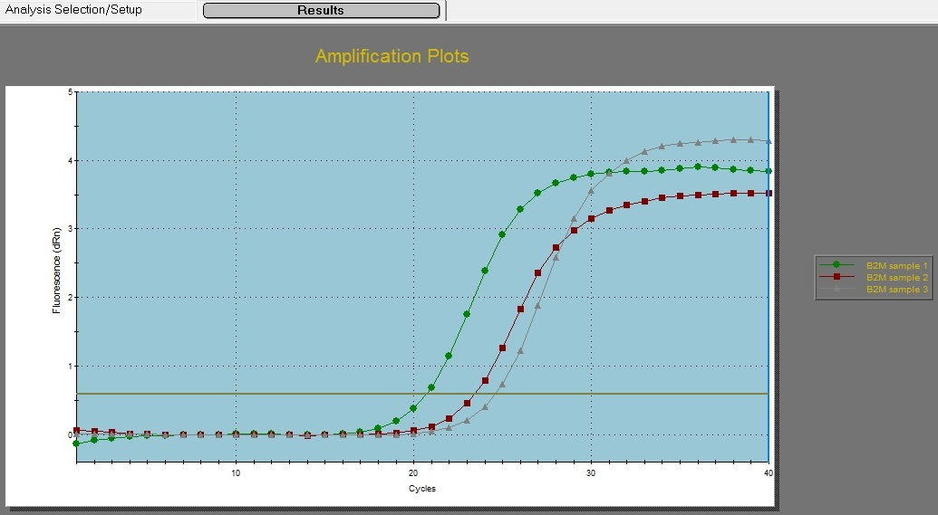
Fig (1): Amplification curves to estimate the variation of gene expression on the RNA of the different samples.

Fig (2): illustrated the positive amplification of 306 bp fragment of IS-1081 gene of M. bovis (samples 7,5,4,2 and 1 positive).
Lane M : 100-600 Pb DNA Ladder
Neg : Negative Control
Pos : Positive Control 306 Pb
Lane : 7, 5, 4,2, 1 Pos.
Lane : 9, 8, 6, 3 Neg.

